FT2232 Board REV1 Assembly Notes:

Front of Board

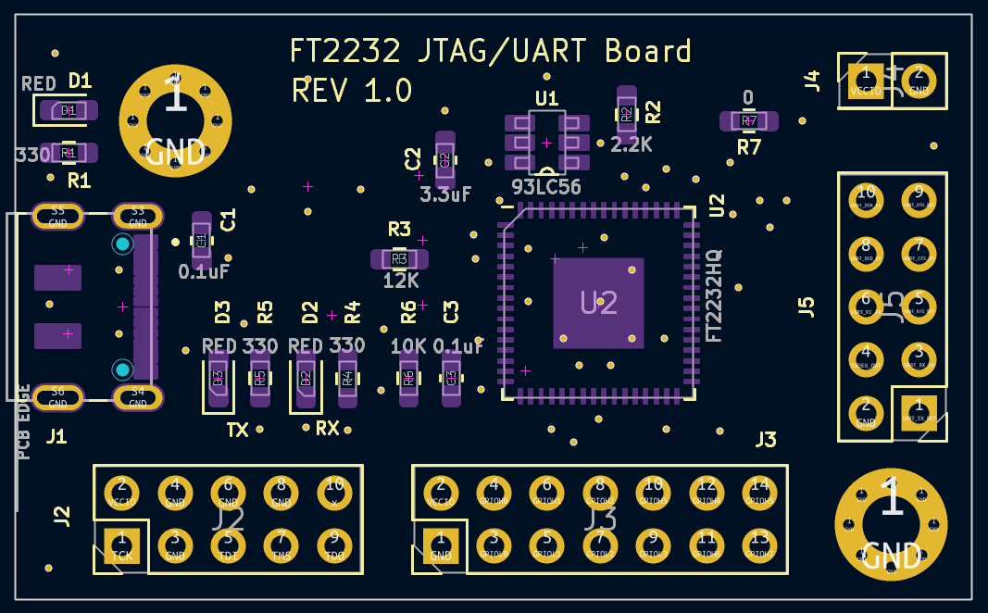

D3,D3,D1 – Red LED 0603 (dot towards line end – cathode)

R1,R4,R5 – 330 Ohm 0603

R6 – 10K 0603

C1, C3 – 0.1uF 0603

C2 – 3.3uF 0603

R2 – 2.2K 0603

R7 – 0 Ohm 0603

R3 – 12K 0603

U1 – 93LC56 (pin 1 at start of text “2P70”)

U2 – FT2232HQ (pin 1 towards C2)

J1 – USB C connector

Back of Board (Flipped)

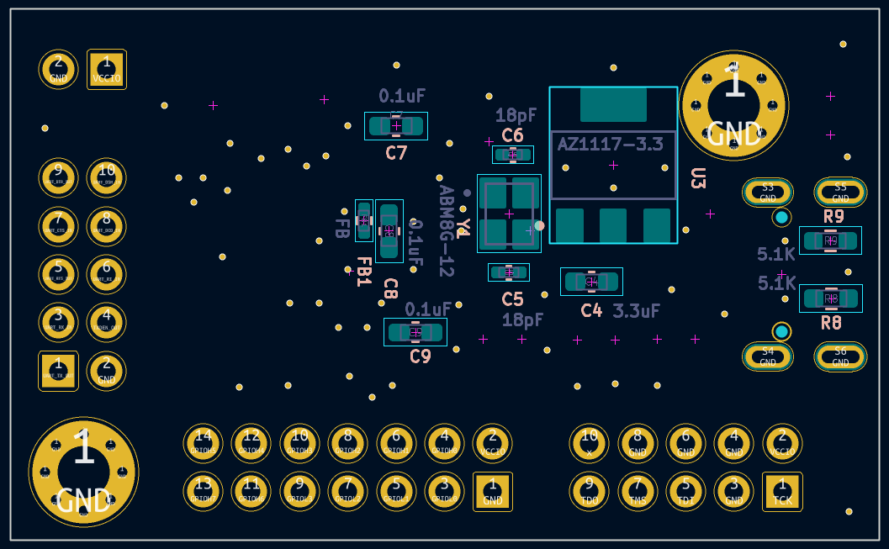

R8,R9 – 5.1K 0603

C4 – 3.3uF

C5,C6 – 18pF

Y1 – AMB8G-12.0000 Oscillator

C7,C9,C8 – 0.1uF 0603

U3 – AZ1117CT-3.3

FB1 – BLM15AG121SZ1D